Solution Architecture

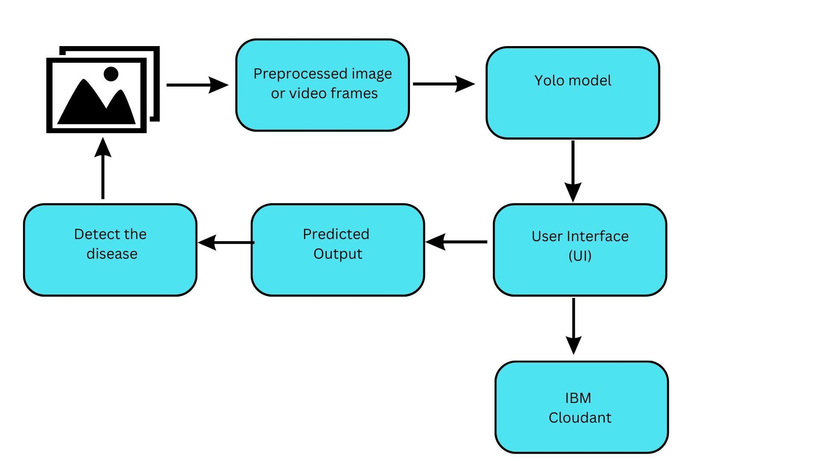

1. The following datasets of Erythema are being collected and categorised into various classes based on its types.
2. The classification of the Erythema datasets are as follows

Erythema Migrans

Erythema Nodosum

Infectious Erythema

Erythema toxicum

Non-Erythema

1. The required Image or the video is processed as per requirements.
2. The preprocessed image is processed with the help of the YOLO Model where disease detection based on its classification of Erythema is done with high accuracy and good learning capabilities.
3. The complete processed Image is sent to the User Interface.
4. From the User Interface, the image is transferred to the IBM Cloudant DB for processed image datasets.
5. In the User Interface, the processed Image is compared based on its dataset classification and the output is predicted.
6. The predicted output is then used to identify the disease.